**Biology: 13. Human Reproduction**

***Please remember to photocopy 4 pages onto one sheet by going A3→A4 and using back to back on the photocopier***

**Syllabus**

**OB31** Use wall charts or other illustrative diagrams to identify and locate the main parts of the male and female reproductive systems

**OB32** Recall that the menstrual cycle lasts about 28 days and that menstruation occurs at the start of the cycle

**OB33** Understand the following in relation to human reproduction:

* fertile period in the menstrual cycle
* sexual intercourse
* fertilisation is the fusion between male and female gametes (sperm and egg) resulting in a zygote;   
  a zygote undergoes cell division and develops within the womb into a foetus
* pregnancy and birth
* growth and puberty

**OB34** Understand that there are many forms of contraception, and that some of these prevent fertilisation

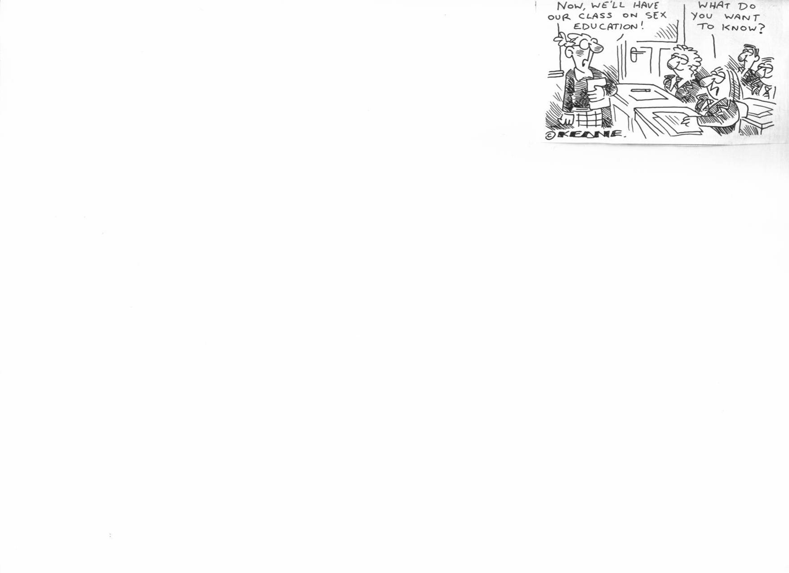

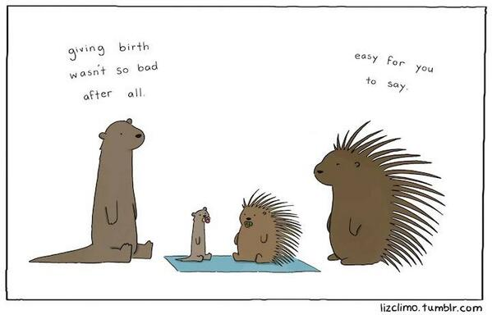

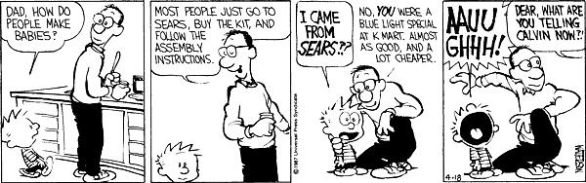

**Student Notes**

**A sex cell is known as a gamete**

The male sex cell (or gamete) is called sperm; the female sex cell (or gamete) is called the egg.

**Fertilisation** occurs when a sperm fuses with an egg

**Fertilisation** occurs in the **fallopian tube**

**The male reproductive system**

|  |  |
| --- | --- |
| **Part** | **Function** |
| Testes | To produce sperm |
| Scrotum | To hold the testes outside body, which favours sperm production (temp = 2oC lower) |
| Sperm duct | To carry sperm from the testes to the penis |
| Prostate gland | To produce fluids which nourish the sperm  (fluid + sperm = semen) |
| Penis | To deliver sperm into the woman’s body |

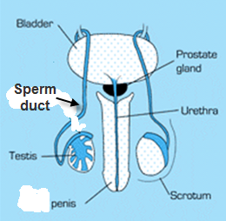

**The female reproductive system**

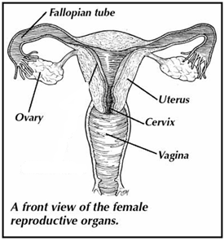

|  |  |
| --- | --- |
| **Part** | **Function** |
| Ovary | To produce eggs |
| Fallopian tube | To carry the egg towards the womb.  Fertilisation occurs here. |
| Womb (uterus) | To hold the baby during pregnancy |
| Cervix | The entrance to the womb |
| Vagina | To hold the penis during sexual intercourse.  To allow childbirth |

**The menstrual cycle**

**Menstruation** is the shedding of the lining of the uterus (commonly referred to as ‘having a period’)

**The menstrual cycle** lasts about 28 days and **menstruation occurs at the start of the cycle**

**Ovulation** is the release of an egg from the ovary and occurs around day 14

A woman is most likely to be fertile (be able to conceive) **for a few days either side of day 14**

**Sexual intercourse** occurs when the erect penis of the male is placed in the vagina of the female

**Fertilisation** is the fusion between male and female gametes (sperm and egg) **resulting in** **a zygote**

**The zygote** undergoes cell division (it then becomes called an ‘embryo’ and the embryo in turn develops within the womb into a foetus

**Pregnancy: the foetus inside the womb**

* **Implantation** occurs when the dividing zygote (ball of cells) attaches itself to the lining of the uterus.
* Human pregnancy usually lasts about 40 weeks.
* After 8 weeks the embryo is recognisable as a human and is the called a foetus.
* Placenta acts as a link between the mother’s bloodstream and that of the developing embryo (it brings in nutrients and takes away waste).

**The birth itself**

1. Contractions begin (muscles in the uterus contract).
2. ‘breaking of the waters’ (liquid – called “amniotic fluid” - escapes).
3. Cervix dilates(widens).
4. The baby is pushed through the cervix (into the vagina)

**Growth and puberty**

**Puberty** is the stage in life during which a person becomes sexually mature

In girls:

1. Puberty brings about an increase in size of ovaries and womb
2. Marks the start of the menstrual cycle.
3. Other characteristics include pubic hair, wider hips, growth spurt, breasts grow, ‘spots’.

In boys:

1. Puberty brings about an increase in the size of the penis and testes.
2. Marks the start of semen production.
3. Other characteristics include pubic, facial and body hair; growth spurt; deeper voice, increased muscle, ‘spots’.

**Contraception**

**Contraception** involves the prevention of a woman getting pregnant.

There are many forms of contraception:

1. Using a condom.
2. Taking ‘the pill’ which prevents an egg forming or being released in the ovary.
3. Surgery to close off the sperm ducts or fallopian tubes.

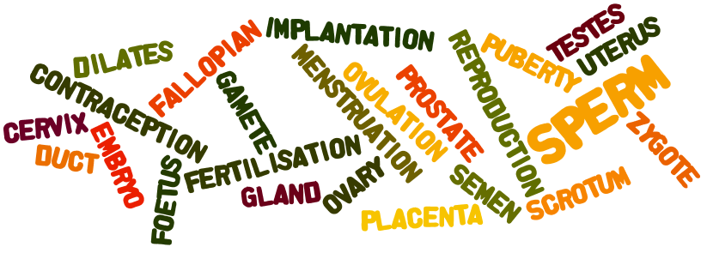**Hard Feckin’ Words – do you understand the meaning of each of the words below?**

Reproduction/ Sperm/ Semen/ Gamete / Fertilisation / Fallopian tube / Testes/ Scrotum/ Sperm duct/ Prostate gland/ Ovary/ Uterus/ Cervix/ Menstruation/ Ovulation/ Zygote/ Embryo/ Foetus/ Implantation/ Placenta/ Dilates/ Puberty/ Contraception

**Exam Questions**

1. [2008]

Explain the term fertilisation.

1. [2007 OL][2011 OL]

The diagram shows the male reproductive system.

1. Identify the part labelled A.
2. What is the name of the substance produced by B?



1. [2010 OL]

The diagram shows part of the female reproductive system.

Study the diagram and answer the questions below.

1. An egg (female gamete) is released from the part labelled ______.
2. The fusion (joining) of the egg with the sperm usually takes place in the part labelled _______.
3. During pregnancy the baby develops in the part labelled _______.



1. [2006 OL][2009 OL]

Name the parts of the female reproductive system labelled A and B in the diagram on the right.

1. [2008]
2. Mark clearly on the diagram, using an arrow and the label S, where the semen (liquid containing sperm) was released into the female.
3. Mark clearly on the diagram, using an arrow and the label F, where fertilization took place.
4. [2009 OL]

What is the name of the gamete produced by the ovaries?

1. [2009]

The diagram shows a sperm. The tail enables the sperm to swim.

1. Why does the sperm need to be able to swim?
2. Where does fertilisation occur?
3. [2006]

What happens in the ovary during the fertile period of the menstrual cycle?

1. [2006]

What happens to the lining of the uterus during the fertile period of the menstrual cycle?

1. [2008]

State two events that occur in the hours before birth and one event that takes place shortly after the baby is born.

1. [2011]

The diagram shows a baby in the womb.

The placenta and umbilical cord are labeled.

1. Give two functions of the placenta.
2. What is the function of the umbilical cord, which connects the baby to the placenta?
3. Describe, briefly, four events that occur at the end of pregnancy (i.e. just before birth, at birth and just after birth).
4. [2012]
5. What is contraception?
6. Name one form of contraception.
7. [2012 OL]

Answer the following questions on human reproduction.

1. The fusion (joining) of the egg with the sperm is called _________
2. There are many methods of contraception. Name one method.
3. The menstrual cycle lasts about _______ days.

**Exam Solutions**

1. Fertilisation is the fusion between a sperm and an egg.
2. Penis
3. Sperm
4. B
5. A
6. C
7. A: Ovary

B: Uterus

1. Vagina (the bottom section)
2. The fallopian tube (curved section on top)
3. Egg
4. To meet the egg
5. In the fallopian tube
6. Ovulation/ release of egg (gamete)
7. The lining thickens/ rich blood supply/prepares for implantation
8. Before:

Contractions (muscles in the uterus contract)/ ‘breaking of the waters’ (liquid, or amniotic fluid or fluid escapes)/ cervix dilates (widens)/ baby is pushed through the cervix (into the vagina)

After:

Umbilical cord is cut/ placenta separates from the uterus/ placenta is expelled/ breasts produce milk

1. Food passes from mother to baby/ oxygen passes from mother to baby/ wastes (CO2, urea…) pass from baby to mother/ antibodies pass from mother to baby/ produces hormones (progesterone)/ water passes from mother to baby …
2. Carry nutrients or named nutrients to baby/ carry wastes from baby / transport
3. Uterus contracts/ baby is moved to cervix/.cervix opens (dilates)/ amniotic sac breaks (the water break)/ baby is pushed out/ umbilical cord is tied and cut/ the afterbirth (placenta and umbilical cord) is expelled/ breasts produce milk/ breast milk contains food and antibodies/ bonding between mother and baby…
4. Prevention of the fusion of gametes (sperm and egg)/

Prevention of fertilisation/ prevention of pregnancy

1. Breast feeding may prevent ovulation/ diaphragm/ condom/ pill/ IUD (intrauterine devices)/ spermicides/ bar (hormonal implant)/ rhythm method (intercourse outside the woman’s fertile time)…
2. Fertilisation
3. Pill / coil / IUD (intra uterine device) / condom / diaphragm / spermicides or any correct example
4. 28 days

**Other Test Questions**

1. What is the male sex cell called?
2. What is the female sex cell called?
3. On what days of a girl’s menstrual is she most fertile?
4. Why is she most fertile on these days?
5. What is the function of the placenta?
6. Label each of the parts of the male and the female reproductive systems.

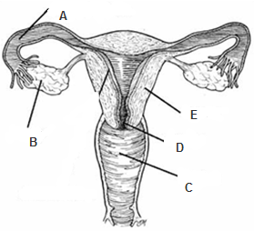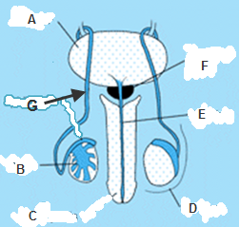

**Assisted Human Reproduction**

Fertility problems affect one in six couples and it’s getting closer to one in five. Experts estimate it will rise to one in four by the end of the decade.

Each year between 2500 and 3000 babies are born in Ireland as a result of IVF (In Vitro Fertilisation).

Typical cost of IVF treatment is €4500!

It is therefore quite likely that one of you will have been born as a result of some part of this process. Is there any reason why that might be something to keep secret?

Why are some people embarrassed by this?

Here’s one you didn’t know: almost all donated sperm comes from Denmark and almost all donated eggs come from Spain or Ukraine.

Is it right to sell embryos?

Is it okay to destroy embryos?

Is it okay to experiment on embryos? – what about if these experiments lead to discoveries that will save babies’ lives?

At what stage is the embryo alive and when does it have rights

What right do children have to know their genetic parents?

If, at the moment of fertilisation, a different sperm combined with the egg, what consequence would it have?

Remember there were millions of sperm in this ‘chase’ so the chances of a given sperm getting to the egg first are over one million-to-one.

A man continually makes sperm throughout his life but a woman is born with a certain amount of eggs and doesn’t grow more.

**On any given day, sexual intercourse takes place 120 million times on earth.**

Humans are a quickly proliferating species, and about 4% of the world’s population have sex on any given day.

**The largest cell in the human body is the female egg and the smallest is the male sperm.**

While you can’t see skin cells or muscle cells, the ovum is typically large enough to be seen with the naked eye with a diameter of about a millimeter. The sperm cell, on the other hand, is tiny, consisting of little more than nucleus.

**Every human spent about half an hour as a single cell.** All life has to begin somewhere, and even the largest humans spent a short part of their lives as a single celled organism when sperm and egg cells first combine. Shortly afterward, the cells begin rapidly dividing and begin forming the components of a [tiny embryo](http://www.babycenter.com/pregnancy-fetal-development-index).

**By the way - there are too many of us alive on the planet right now**

Over-population is one of the greatest problems affecting the planet; what, if anything, can or should we do about it?

**Is the sperm or egg alive?**

IVF with an embryo frozen for almost 20 years has resulted in a healthy birth, beating the previous record by seven years

**What causes period pain?**  
Contractions of the uterus cause this type of pain Waves of contraction happen continuously but they are stronger during menstruation, when they throw off the lining of the uterus so that a new one can grow ready for the next menstrual cycle. They reduce the blood supply to the uterus and the resulting lack of oxygen causes pain.

**How old are you?**

Just like a chicken, your life started off with an egg. Not a chunky thing in a shell, but an egg nonetheless. However, there is a significant difference between a human egg and a chicken egg that has a surprising effect on your age. Human eggs are tiny. They are, after all, just a single cell and are typically around 0.2mm across – about the size of a printed full stop. Your egg was formed in your mother – but the surprising thing is that it was formed when she was an embryo. The formation of your egg, and the half of your DNA that came from your mother, could be considered as the very first moment of your existence. And it happened before your mother was born. Say your mother was 30 when she had you, then on your 18th birthday you were arguably over 48 years old.  
<http://www.guardian.co.uk/science/2013/jan/27/20-human-body-facts-science?CMP=twt_gu>

**Did you know that you won the lottery?**

We have always assumed that ‘we’ will be around forever; not only that but we wonder how long it will be before we can colonise other planets and solar systems. We conveniently ignore the fact that our being here in the first place may be nothing more that the fortutitous result of an incredible set of co-incidences.

Do you believe that your existence is preordained?  
I’m not sure what the position of the mainstream religions is on this (or even if they have a position) but think about it;  when your mom and dad had sex nine months before you were born that one single ejaculation from your father (I do hope you’re not reading this over your morning cornflakes) contained probably two million healthy sperm – and only one of them got to combine with your mother’s egg.  
(Apparently the total number of spermatozoa in the ejaculate should be at least 40 million, but it is quite surprising how many dead and abnormal sperm can be present in a ‘normal’ sample.)

And this combination lead to you. Now if any of those other two million sperm got there ahead of yours then it wouldn’t be you reading this right now – it would be a brother or sister – and you wouldn’t exist! So if your folks had decided to wait until Eastenders was over instead of rushing upstairs in a mad fit of passion then *you* would not be you – you would be your brother (or sister)! I’m telling you – this stuff is mad. Why had nobody told you this before?

So next time you rip up your lottery ticket and complain that you never win anything just think about this – you’ve already won the lottery, and it couldn’t have been a bigger prize!